STEP-BY-STEP
NEW TO SCRATCH? CREATE YOUR FIRST SCRATCH PROJECT!

GOAL:
In this activity, you will follow the Step-by-Step Intro in the Tips Window to create a dancing cat in Scratch. Once you have completed the steps, experiment by adding other Scratch blocks to make the project your own.

Start Here:
- Login to your scratch account
- Create a new project by clicking the “Create” button on the top blue bar of the screen
- Click the “tutorials” button, then select “Getting Started”
- Watch the tutorial video, then complete the tutorial tasks on the next 3 tutorial slides
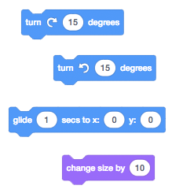
- Add a backdrop to your project
- Add another sprite to your project
  - Have your sprite do at least 2 of the following:
    - Try recording your own sounds.
    - Create different backdrops.
    - Turn your project into a dance party by adding more dancing sprites!
    - Try designing a new costume for your sprite.

- Experiment to make the project your own!
- Upload the finished project to the “Step-by-Step” class studio
  - Click the orange share button
  - Add a title, instructions and credits as needed
  - Click add to studio
  - Select “Step by Step”
  - Click “Okay” button
- Complete the “Step-by-Step” reflection google form found on the 6th grade MMS STEM website.

