CHARACTERS
DO YOU WANT TO CREATE YOUR OWN SCRATCH BLOCKS?
Experiment with the Make a Block feature in Scratch! In this project, you will create your own blocks that define two behaviors for two different characters.
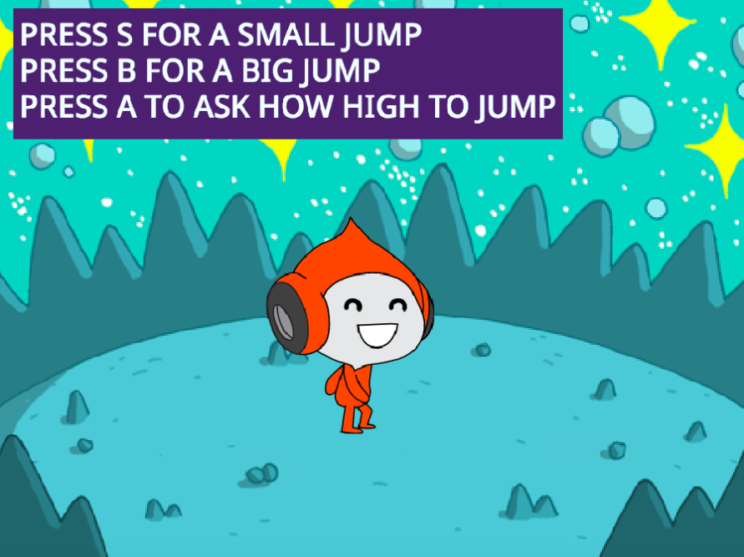

START HERE
- Login to your scratch account
- Click your name in the top right corner and select my class
- Click on the “CREATE” button on the top toolbar
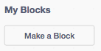
- Choose from the library, paint, or upload two sprite characters.
- Click on the Make a Block button in the My Blocks category to
create and name your block.

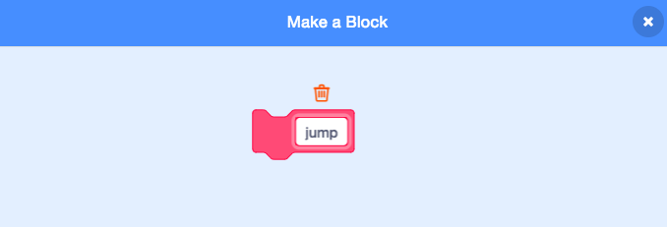
- Add blocks under the Define block to control
what your custom block will do.

- Experiment with using your block to program
your characters’ behaviors.

- Repeat, until you are happy with your work!
- Upload finished project to the class studio called “Characters”

- Complete the “Characters” Reflection on the MMS STEM website
