CONVERSATIONS
WHAT ARE DIFFERENT WAYS TO COORDINATE INTERACTIONS BETWEEN SPRITES?
In this activity, you'll explore different ways to program sprites to have conversations! Experiment with timing and explore using broadcast by remixing a joke project.

START HERE
- Login to your scratch account
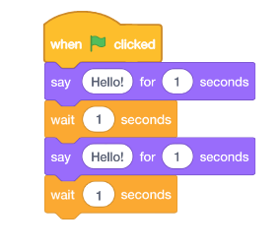
- Click your name in the top right corner and select my class
- Open the class studio called “Conversations”
- Select the project called “Conversations: START HERE”
- Click “REMIX” to open your own copy of the project
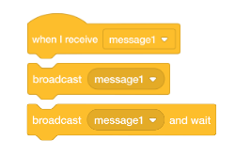
- Investigate the code to see how the wait and say blocks are used to coordinate the conversation.
- Remix the project to use the “broadcast” and “when I receive” blocks instead of” wait blocks”.
- Upload finished project to the class studio called “Conversation”

- Complete the “Conversations” Reflection on the MMS STEM website

