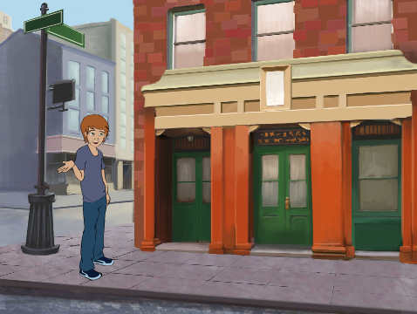
SCENES
WHAT IS THE DIFFERENCE BETWEEN THE STAGE AND SPRITES?
In this activity, you will create a project that experiments with backdrops, like a story with multiple scenes or a slideshow.

START HERE
- Login to your scratch account
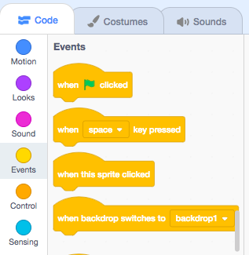
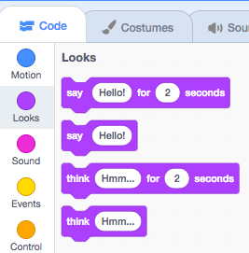
- Click your name in the top right corner and select my class
- Open a new project with the “create” button
- Choose from the library, paint, or upload multiple backdrops (at least 3) into your project.
- Experiment with blocks from the Looks and Events categories to initiate switching backdrops.
- Add scripts to the stage and sprites to coordinate what happens when the backdrop changes in your project!
- Upload finished project to the class studio called “Scenes”

- Complete the “Scenes” Reflection on the MMS STEM website
