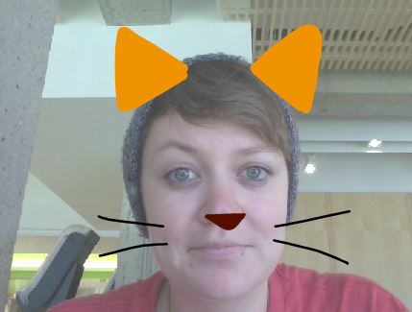
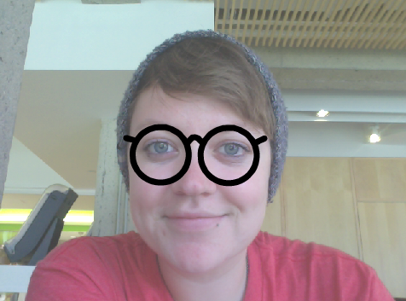
VIDEO SENSING
HOW CAN YOU USE VIDEO SENSING IN YOUR SCRATCH PROJECTS?
Did you know that you can make your Scratch projects interactive through a webcam? Explore this advanced Scratch concept by creating a project that incorporates the video sensing feature.

START HERE
- Login to your scratch account
- Open an existing Scratch project or start a new project to add video sensing.
- Click on Extensions.
- Click on Video Sensing.
- Check out blocks for video sensing in the Sensing category.
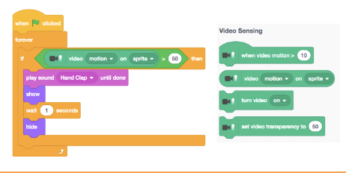
- Experiment with video on, turn video, and set video transparency to blocks to program your project to sense video motion.

- Upload finished project to the class studio called “Video Sensing”

- Complete the “Video Sensing” Reflection on the MMS STEM website

