BUILD-A-BAND
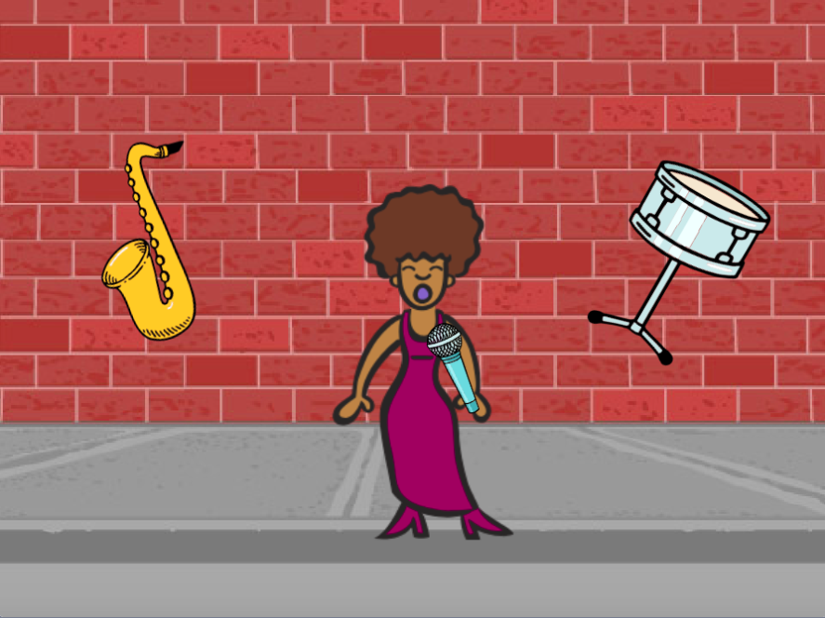
HOW CAN YOU UTILIZE SCRATCH TO CREATE SOUNDS, INSTRUMENTS, BANDS, OR STYLES OF MUSIC THAT REPRESENT THE MUSIC YOU LOVE MOST?

GOAL:
In this activity, you will build your own music-inspired Scratch project by pairing sprites with sounds to design interactive instruments.

Start Here:
- Login to scratch
- Click your name in the top right corner and select my class
- Click on the “CREATE” button on the top toolbar
- Create a Sprite
- Add at least 3 instruments to your project using the sprite library
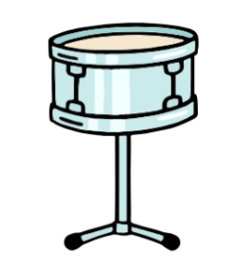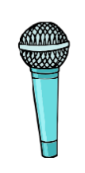
- Experiment with ways to make your sprites interactive
See inspiration for coding this below, but add to the list!
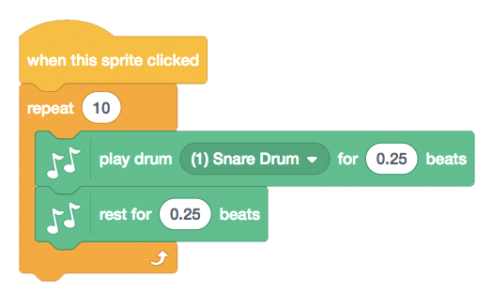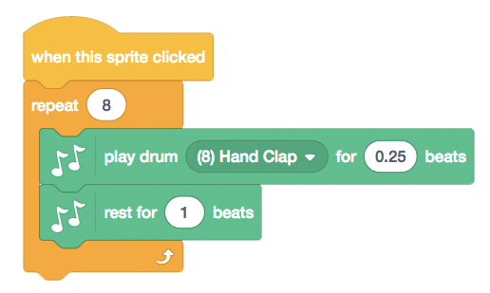
- Try adding a repeat block to make things play more than once
- Try to import or add your own sounds with the sound editor
- Try playing with the tempo blocks to speed up or slow down the rhythm.
- Share the finished band project to the class studio called “Build a Band”
- Complete the “Build a Band” Reflection sent to your email

