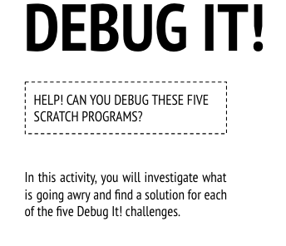
Start Here:
- Login to scratch
- Click your name in the top right corner and select my class
- Click on the Class Studio called “Debug It”
- Click on the project called “Debug-it 1.1”
- Read the instructions in the instructions box to know what you need to repair in the coding for this project.
  - When the green flag is clicked, both Gobo and Scratch Cat should start dancing, but only Scratch Cat starts dancing!
- Click Remix
- Fix the code
- Share the debugged project to the class studio called “Debug-it SUCCESS”
- Finished early?
  - Go back to the “Debug-it” studio and try to debug and share:
    - “Debug-it 1.2”
      - In this project, when the green flag is clicked, the Scratch Cat should start on the left side of the stage, say something about being on the left side, glide to the right side of the stage, and say something about on the right side. It works the first time the green flag is clicked, but not again.
    - “Debug-it 1.3”
      - The Scratch Cat should do a flip when the space key is pressed, but when the space key is pressed, nothing happens!
    - “Debug-it 1.4”
      - In this project, the Scratch Cat should pace back and forth across the stage, when the Scratch Cat is clicked, but the Scratch Cat is flipping out -- and is walking upside down!
    - “Debug-it 1.5”
      - In this project, when the green flag is clicked, the Scratch Cat should say "Meow, meow, meow!" in a speech bubble and as a sound, but the speech bubble happens before the sound -- and the Scratch Cat only makes one "Meow" sound!
- Complete the “Debug-it” Reflection sent to your email

