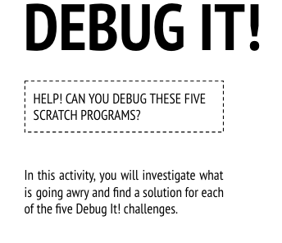
Start Here:
- Login to scratch
- Click your name in the top right corner and select my class
- Click on the Class Studio called “Debug It”
- Click on the project called “Debug-it 2.1”
- Read the instructions in the instructions box to know what you need to repair in the coding for this project.
  - Scratch Cat wants to show you a dance. When you click on him, he should do a dance while a drum beat plays along with him. However, as soon as he starts to dance he stops but the drumming continues without him! How do we fix this program?
- Click Remix
- Fix the code
- Share the debugged project to the class studio called “Debug-it SUCCESS”
- Finished early?
  - Go back to the “Debug-it” studio and try to debug and share:
    - “Debug-it 2.2”
      - In this project, when the green flag is clicked Pico should move towards Nano. When Pico reaches Nano, Pico should say “Tag, you’re it!” and Nano says “My turn!” But something is wrong! Pico doesn’t say anything to Nano. How do we fix the program?
    - “Debug-it 2.3”
      - This project is programmed to draw a happy face but something's not quite right! The pen continues to draw from one of the eyes to the smile when it should not be doing so. How do we fix the program?
    - “Debug-it 2.4”
      - In this project, when the green flag is clicked an animation of a flower growing begins and stops once it has fully bloomed. But something's not quite right! Instead of stopping when all the petals have bloomed, the animation starts all over. How do we fix this program?
    - “Debug-it 2.5”
      - In this project, the Happy Birthday song starts playing when the green flag is clicked. Once the song finishes, instructions should appear telling us to "click on me to blow out the candles!" But something is not working! The instructions to blow out the candles are shown while the birthday song is playing rather than after it finishes. How do we fix this program?
- Complete the “Debug-it” Reflection sent to your email

