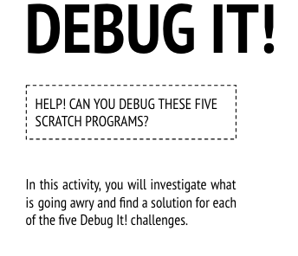
Start Here:
- Login to scratch
- Click your name in the top right corner and select my class
- Click on the Class Studio called “Debug It”
- Click on the project called “Debug-it 3.1”
- Read the instructions in the instructions box to know what you need to repair in the coding for this project.
  - In this project, the Scratch Cat teaches Gobo to meow. But when it's Gobo's turn to try -- Gobo stays silent. How do we fix the program?
- Click Remix
- Fix the code
- Share the debugged project to the class studio called “Debug-it SUCCESS”
- Finished early?
  - Go back to the “Debug-it” studio and try to debug and share:
    - “Debug-it 3.2”
      - In this project, the Scratch Cat is supposed to count from 1 to the number the user provides. But the Scratch Cat always counts to 10. How do we fix the program?
    - “Debug-it 3.3”
      - In this project, the Scratch Cat is doing a roll call with Gobo's friends: Giga, Nano, Pico, and Tera. But everything is happening all at once! How do we fix the program?
    - “Debug-it 3.4”
      - In this project, the Scratch Cat and Gobo are practicing their jumping routine. When Scratch Cat says "Jump!", Gobo should jump up and down. But Gobo isn't jumping. How do we fix the program?
    - “Debug-it 3.5”
      - In this project, the scene changes when you press the right arrow key. The star of the project -- a dinosaur -- should be hidden in every scene except when the scene transitions to the auditorium backdrop. In the auditorium, the dinosaur should appear and do a dance. But the dinosaur is always present and is not dancing at the right time. How do we fix the program?
- Complete the “Debug-it” Reflection sent to your email

