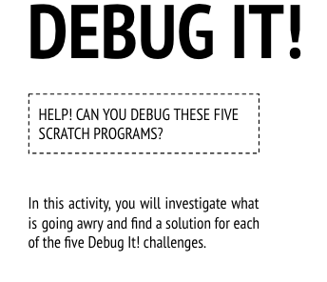
Start Here:
- Login to scratch
- Click your name in the top right corner and select my class
- Click on the Class Studio called “Debug It”
- Click on the project called “Debug-it 4.1”
- Read the instructions in the instructions box to know what you need to repair in the coding for this project.
  - In this project, the "Inventory" list should be updated every time Scratch Cat picks up a new item. But Scratch Cat can only pick up the laptop. How do we fix the program?
- Click Remix
- Fix the code
- Share the debugged project to the class studio called “Debug-it SUCCESS”
- Finished early?
  - Go back to the “Debug-it” studio and try to debug and share:
    - “Debug-it 4.2”
      - In this project, Scratch Cat gets 10 points for collecting Yellow Gobos and loses 10 points for colliding with Pink Gobos. But something isn't working. How do we fix the program?
    - “Debug-it 4.3”
      - In this project, Scratch Cat is thinking of a number between 1 and 10. But something is wrong with the guess checking -- it doesn't work consistently. How do we fix the program?
    - “Debug-it 4.4”
      - In this project, the "# of hits" display should increase by 1 every time the Scratch Cat is hit by a tennis ball. But the "# of hits" increases by more than 1 when Scratch Cat is hit. How do we fix the program?
    - “Debug-it 4.5”
      - In this project, Scratch Cat is navigating a maze to get to the yellow rectangle. But Scratch Cat can walk through walls. How do we fix the program?
- Complete the “Debug-it” Reflection sent to your email

