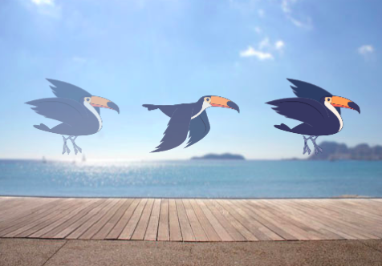
IT’S ALIVE!
HOW CAN YOU TAKE AN IMAGE OR A PHOTO AND MAKE IT COME ALIVE?
In this activity, you will explore ways of bringing sprites, images, and ideas to life as an animation by programming a series of costume changes.

Start Here:
- Login to scratch
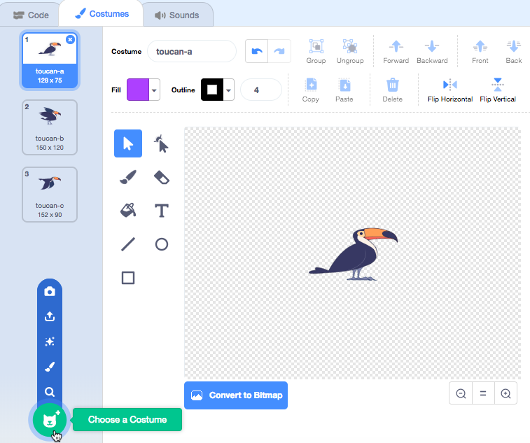
- Click your name in the top right corner and select my class
- Click on the “CREATE” button on the top toolbar
- Choose a sprite.
- Add a different costume.
- Add blocks to make the image come alive.
  - Try sketching your animation ideas on paper first – like a flipbook.
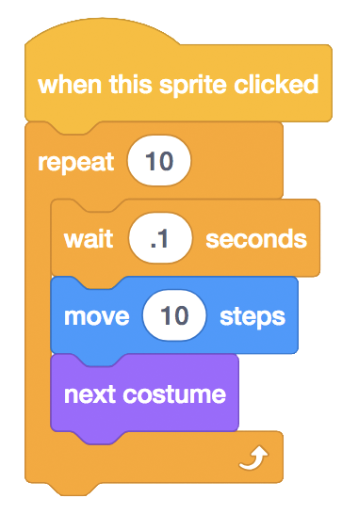
  - Experiment with different blocks and costumes until you find something you enjoy.
- Repeat!
- Share the finished band project to the class studio called “It’s Alive”

- Complete the “It's Alive” Reflection sent to your email

