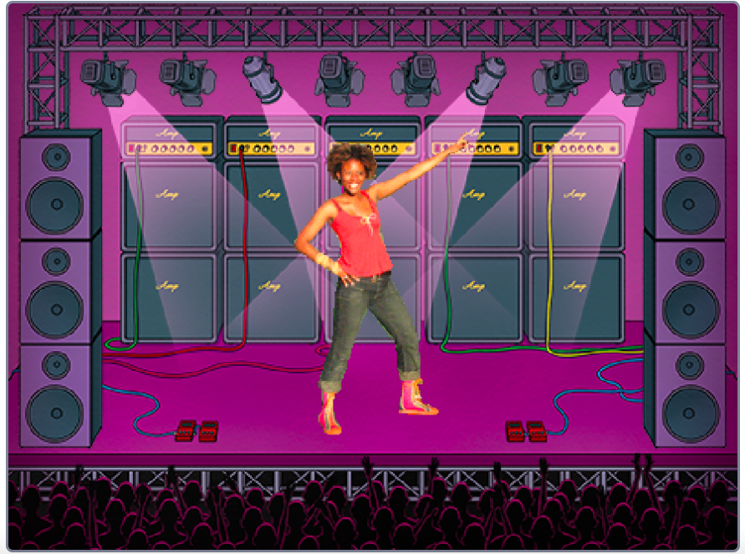
MUSIC VIDEO
HOW CAN YOU COMBINE ANIMATION WITH MUSIC TO CREATE YOUR OWN SCRATCH-INSPIRED MUSIC VIDEO?
In this project, you will explore ideas related to theatre, song, dance, music, drawing, illustration, photography, and animation to create a personalized music video!
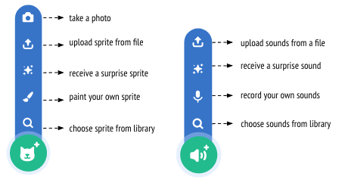
START HERE
- Login to your scratch account
- Click your name in the top right corner and select my class
- Click on the “CREATE” button on the top toolbar
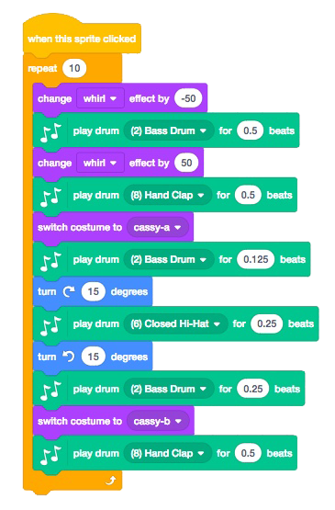
- Add sound.

- Create and animate a sprite.
- Make them interact together!
- Use costumes to help bring your animations to life!
- Make your sprite interactive by adding scripts that have the sprite respond to clicks, key presses, and more.
- Add instructions on the project page to explain how people can interact with your program.
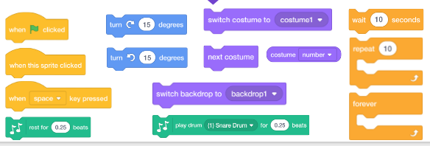
- Upload finished project to the class studio called “Music Video”
- Complete the “Music Video” Reflection sent to your email
Here are some blocks to try for this project:

