ORANGE SQUARE,
PURPLE CIRCLE
WHAT PROJECT CAN YOU CREATE THAT INCLUDES AN ORANGE SQUARE AND A PURPLE CIRCLE?
GOAL:
In this challenge, you’ll create a project that includes an orange square and a purple circle. What will you create?

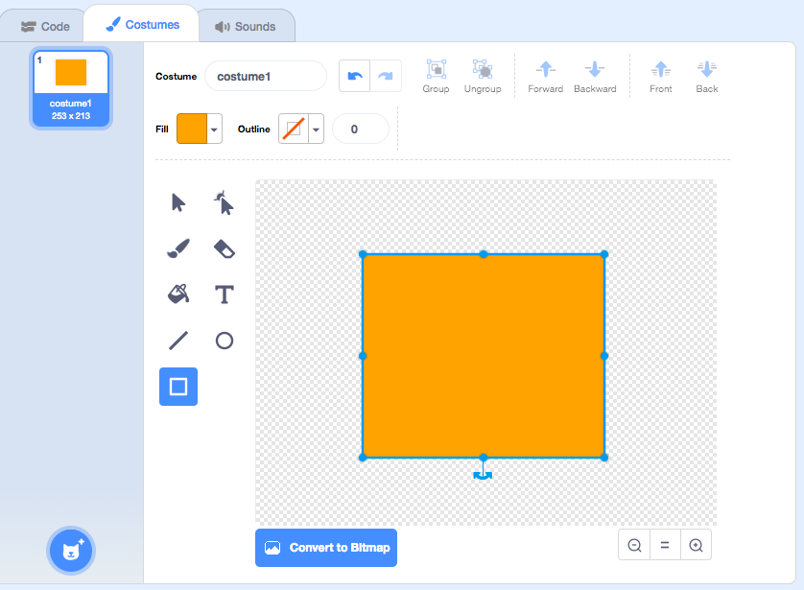
- Login to your scratch account
- Click “Create” to start a new project
- Draw your sprites using the PAINT EDITOR
  - Sprite 1: orange square
  - Sprite 2: purple circle
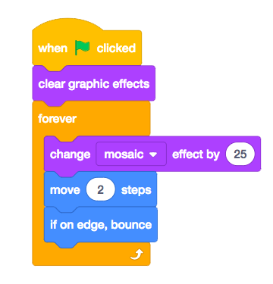
- Add different Looks and Motion blocks to bring your sprites to life.
  - Explore the difference between bitmap mode and vector mode, located at the bottom of the paint editor.
  - Challenge yourself to do more! Add another shape or color.
- Upload your finished project to the class studio called “Orange Square, Purple Circle”
- Complete the reflection on google forms found on the MMS STEAM website.

