DUE DATE: _____________ NAME: _________________
Scratch Choose Your Own Adventure
“Scratching the need for adventure”

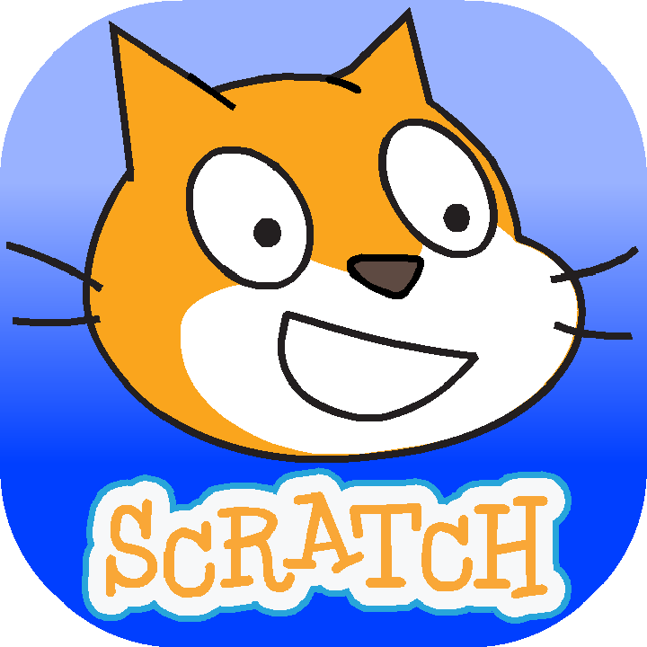
You are going to develop a “Choose your own Adventure” style scracth program that allows you to take a sprit through a multiple scene story where they get to decide which path they will take to complete the story. During the actual scratch program you are going to have to incorperate many different sprites that your main character will have to interact with to escape the challenges that you have created. One of the dynamic challenges that your sprite will have to face is a mini-game (such as a maze, scrolling, or pong style game) that you have created in previous scratch projects.

WHAT YOU NEED TO KNOW TO BE SUCCESSFUL:
Use the following checklist to help you determine what you need to do to complete the codecademy
Choose Your Own Adventure  (Story Tree/Outline) | Before you actually start to program your project create a story tree that details how your story will work and the paths that your sprit can take to get there:
- Map of each outcome in your story: (11 points)
- Outline of what happens at each outome point (2-3 sentences)
- Description of each ending outcome
- Description of how the mini-game ties into the overall story
Scratch Sprits  (Story Characters) | During the course of your Choose Your Own Adventure program your main character must interact with different sprits to complete the adventure, make sure you include:  - One Unique Main Character (stock character that has been edited in some way)  - At least 3 Secondary Characters/Sprits that the main character will interact with through the course of the story  - Dialog between characters  - At least 2 Ending Character/Sprits that conclude the story
Scratch Backgrounds | Each of your “Choices” should include a different background style:  - Story must include at least 5 unique backgrounds throughout the course of the story:  - Mini-game must include at least 1 unique background  - Story ending must include at least 4 unique backgrounds  - Backgrounds must contain at least 4 interactive elements throughout the whole story for the character to touch (ex. door that when touched cause the character to transport to a different place)
Mini-Game Challenge | During the course of your story your character must have to play a mini game to progress in the story, you can use a game style created previously like a maze, scrolling, or pong style game  - Mini-Game MUST include:  - Some interactive element (like touching the wall or touching an end item)  - Either a score counter or game timer program  - Mini-Game has to be used in both your A story and B story

REMEMBER: Play test other “Choose your own Adventure” style scratch programs in the gallery to get a sense of how to make that type of program. When you play test make sure that you are looking inside the code to see how they created their adventure and see if you can use any of that programming in yours.
Name: ________________________
GRADING RUBRIC: Codecademy
CATEGORY | 4 | 3 | 2 | 1
Story Tree/Outline:  _______/4 (2x)  ________/8 | Story presentation has ALL of the listed descriptions from the directions: Map of each outcome in your story: (11 points), Outline of what happens at each outome point (2-3 sentences), Description of each ending outcome,  Description of how the mini-game ties into the overall story | Story presentation has 3 of the 4 listed descriptions from the directions: Map of each outcome in your story: (11 points), Outline of what happens at each outome point (2-3 sentences), Description of each ending outcome,  Description of how the mini-game ties into the overall story | Story presentation has 2 of the 4 listed descriptions from the directions: Map of each outcome in your story: (11 points), Outline of what happens at each outome point (2-3 sentences), Description of each ending outcome,  Description of how the mini-game ties into the overall story | Story presentation has 1 of the 4 listed descriptions from the directions: Map of each outcome in your story: (11 points), Outline of what happens at each outome point (2-3 sentences), Description of each ending outcome,  Description of how the mini-game ties into the overall story
Scratch  SPRITS:  _______/4 | Overall program has ALL of the listed requirements for the sprits contained in the story: One Unique Main Character (stock character edited), At least 3 Secondary Characters/Sprits, Dialog between characters, At least 2 Ending Character/Sprits | Overall program has 3 of the 4 listed requirements for the sprits contained in the story: One Unique Main Character (stock character edited), At least 3 Secondary Characters/Sprits, Dialog between characters, At least 2 Ending Character/Sprits | Overall program has 2 of the 4 listed requirements for the sprits contained in the story: One Unique Main Character (stock character edited), At least 3 Secondary Characters/Sprits, Dialog between characters, At least 2 Ending Character/Sprits | Overall program has 1 of the 4 listed requirements for the sprits contained in the story: One Unique Main Character (stock character edited), At least 3 Secondary Characters/Sprits, Dialog between characters, At least 2 Ending Character/Sprits
Scratch BACKGROUNDS:  _________/4 | Overall program has ALL of the listed requirements for the backgrounds contained in the story: at least 5 unique backgrounds throughout, Mini-game includes at least 1 unique background, Story ending must include at least 4 unique backgrounds, Backgrounds must contain at least 4 interactive elements | Overall program has 3 of the 4 listed requirements for the backgrounds contained in the story: at least 5 unique backgrounds throughout, Mini-game includes at least 1 unique background, Story ending must include at least 4 unique backgrounds, Backgrounds must contain at least 4 interactive elements | Overall program has 2 of the 4 listed requirements for the backgrounds contained in the story: at least 5 unique backgrounds throughout, Mini-game includes at least 1 unique background, Story ending must include at least 4 unique backgrounds, Backgrounds must contain at least 4 interactive elements | Overall program has 1 of the 4 listed requirements for the backgrounds contained in the story: at least 5 unique backgrounds throughout, Mini-game includes at least 1 unique background, Story ending must include at least 4 unique backgrounds, Backgrounds must contain at least 4 interactive elements
Scratch  MINI-GAME:  _________/4 | Overall program has ALL of the listed requirements for the mini-game contained in the story: at least 1 mini-game style, Some interactive element, Either a score counter or game timer program, Mini-Game has to be used in both your A story and B story | Overall program has 3 of the 4 listed requirements for the mini-game contained in the story: at least 1 mini-game style, Some interactive element, Either a score counter or game timer program, Mini-Game has to be used in both your A story and B story | Overall program has 2 of the 4 listed requirements for the mini-game contained in the story: at least 1 mini-game style, Some interactive element, Either a score counter or game timer program, Mini-Game has to be used in both your A story and B story | Overall program has 1 of the 4 listed requirements for the mini-game contained in the story: at least 1 mini-game style, Some interactive element, Either a score counter or game timer program, Mini-Game has to be used in both your A story and B story

TOTAL: _______/20
TEACHER COMMENTS:

